**CREATION OF WEBAPP + MYSQL**

From Webapps select Web App + Mysql

Webapps > Web App + Mysql

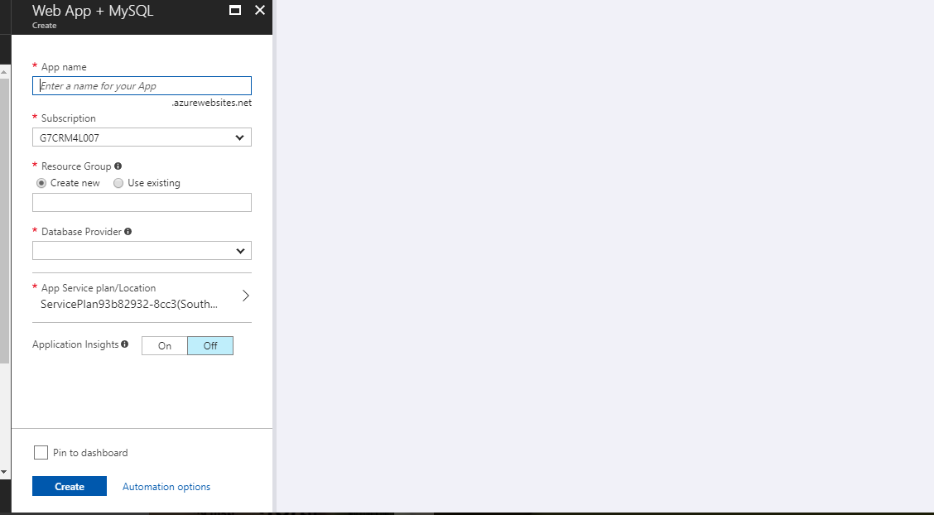

Give name,select subscription,select resource group,

Now we have to select Dataservice Provider

Select Azure database for Mysql from it

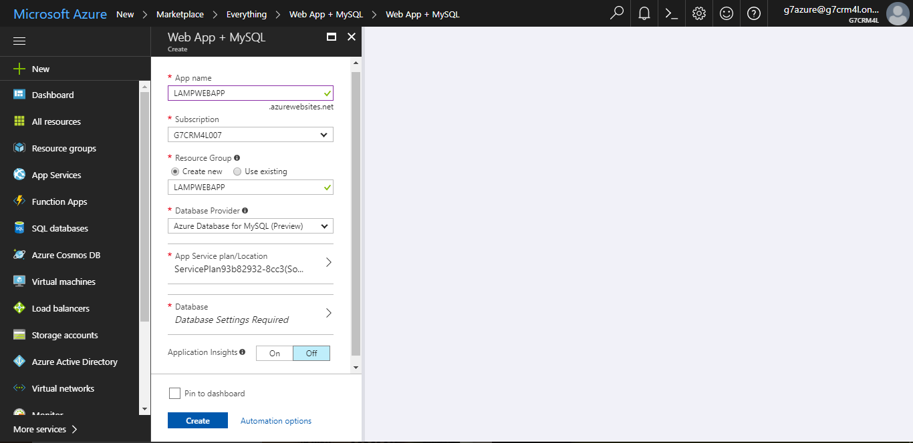

Now we have to select App service plan.Its better to create a new one.Click on **New.**Now give name,location,Price tier

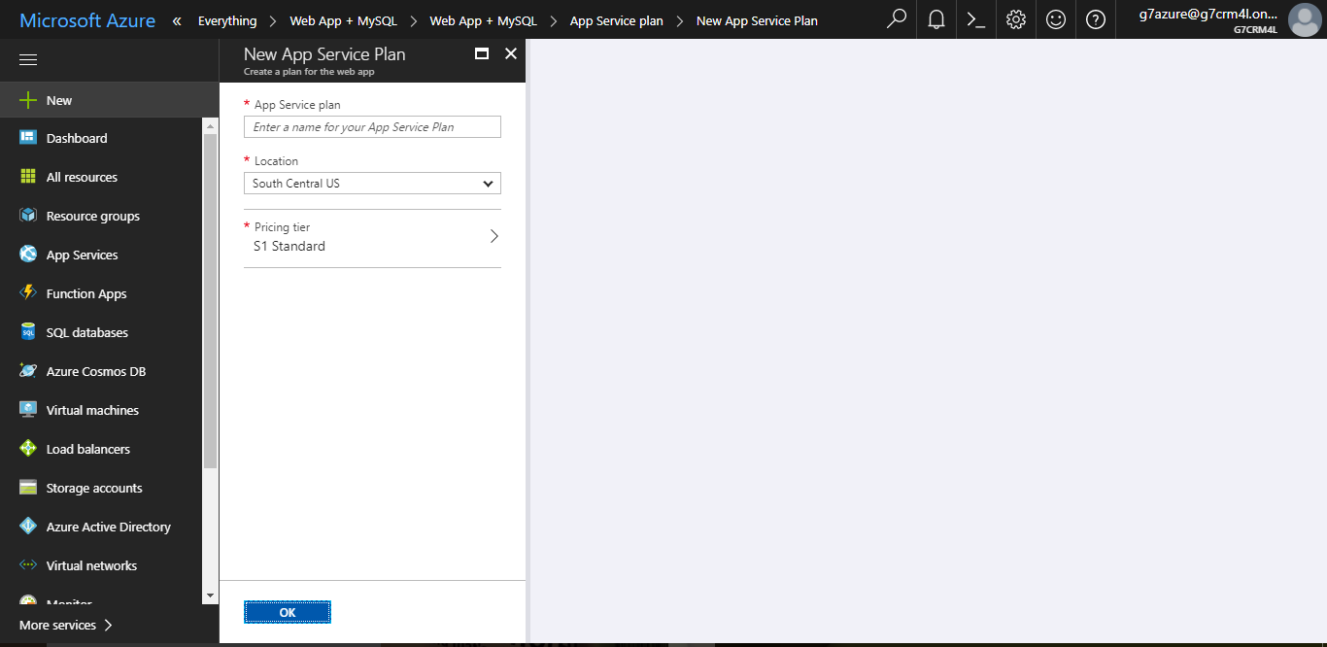

Select free plan from it

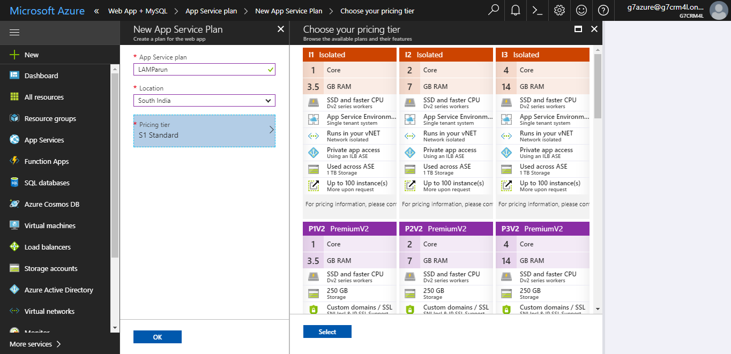

Click on **Ok**

Now we have to select database.

Give server name,Login name,password,version,price tier and database name

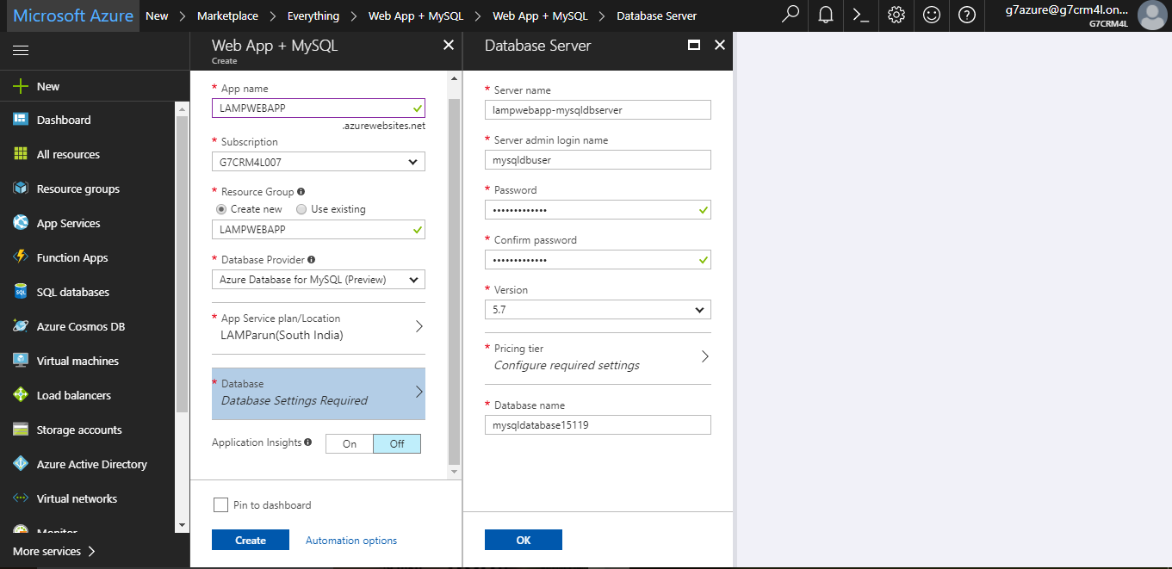

On price tier we can go with basic one.

Click OK

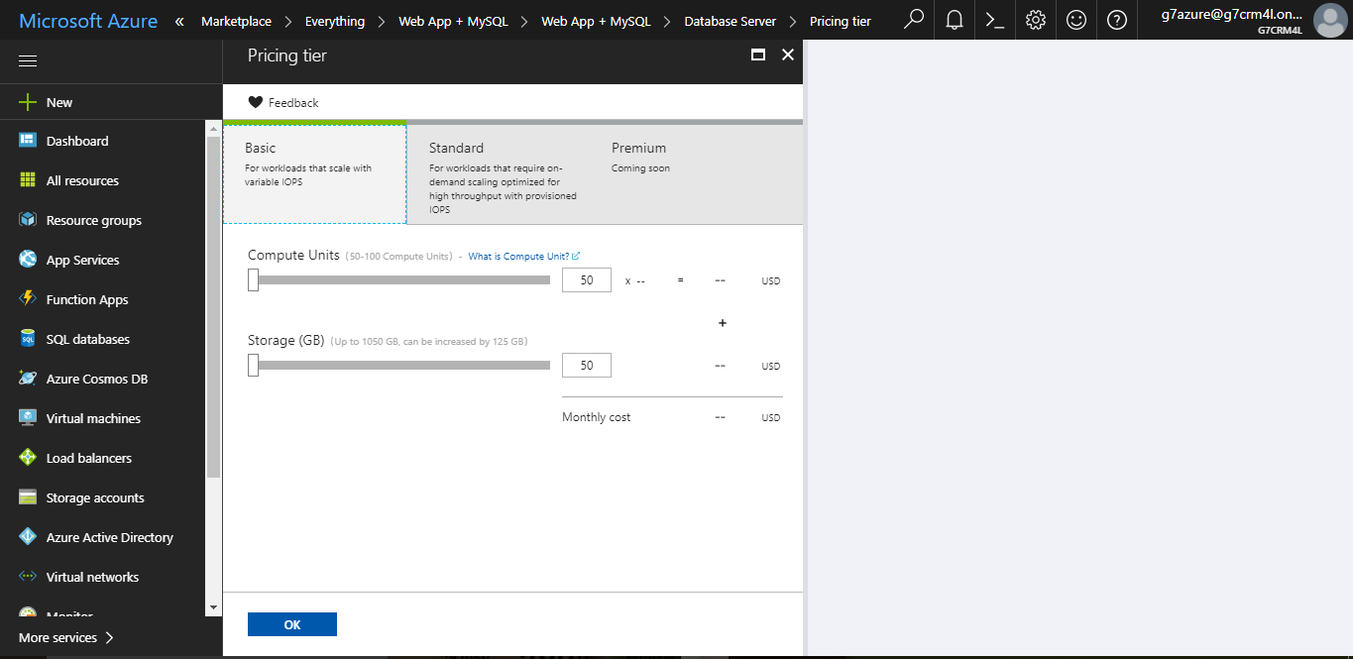

Select the mysql location as we want.Click on Create

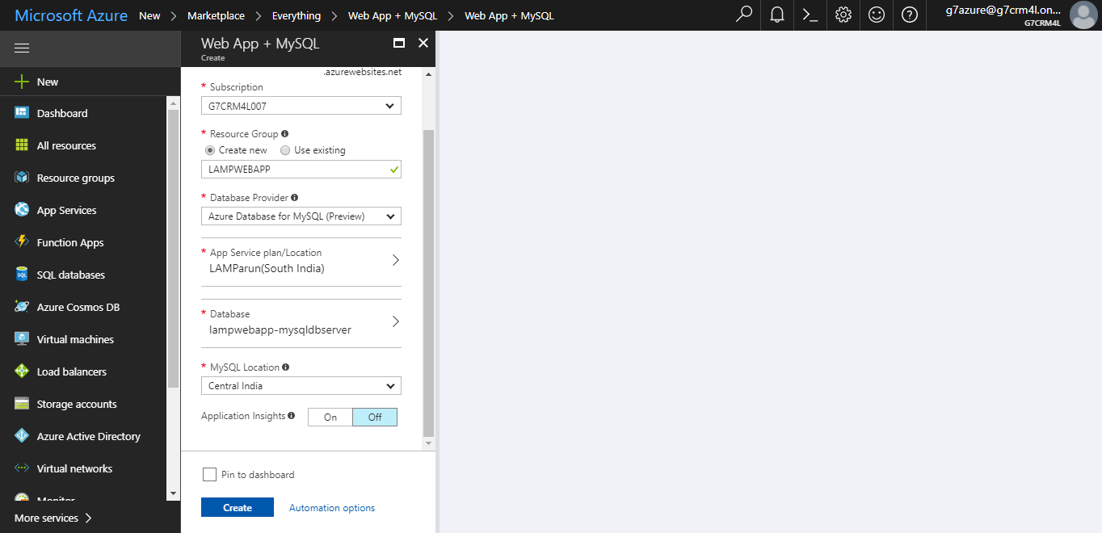

Now go to our resource group and select our database for webapp.From there we want to select deployment credentials.Type ftp deployment name and password

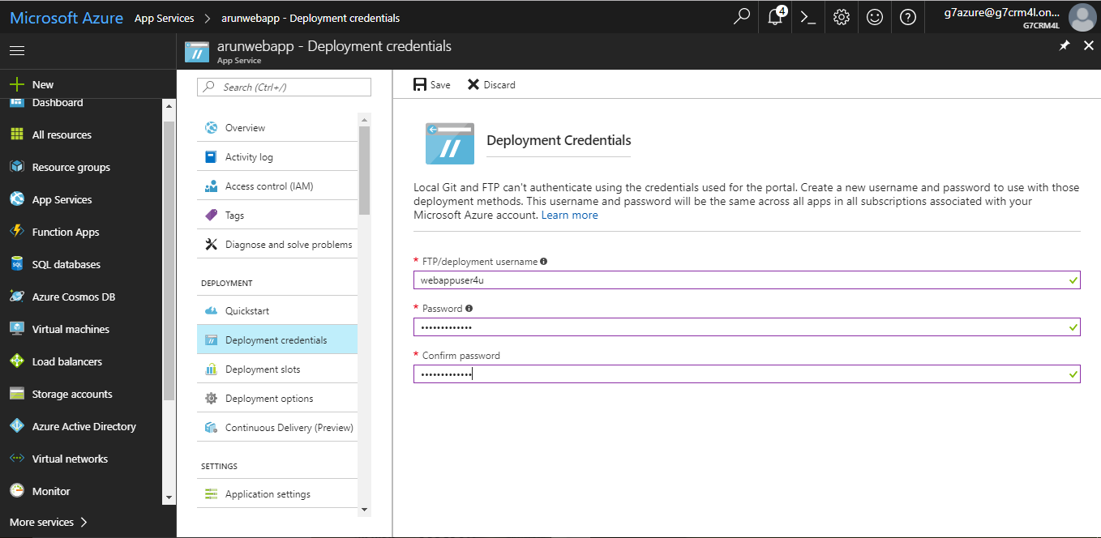

After that go to our webapp and click on reset Public profile.Click Yes

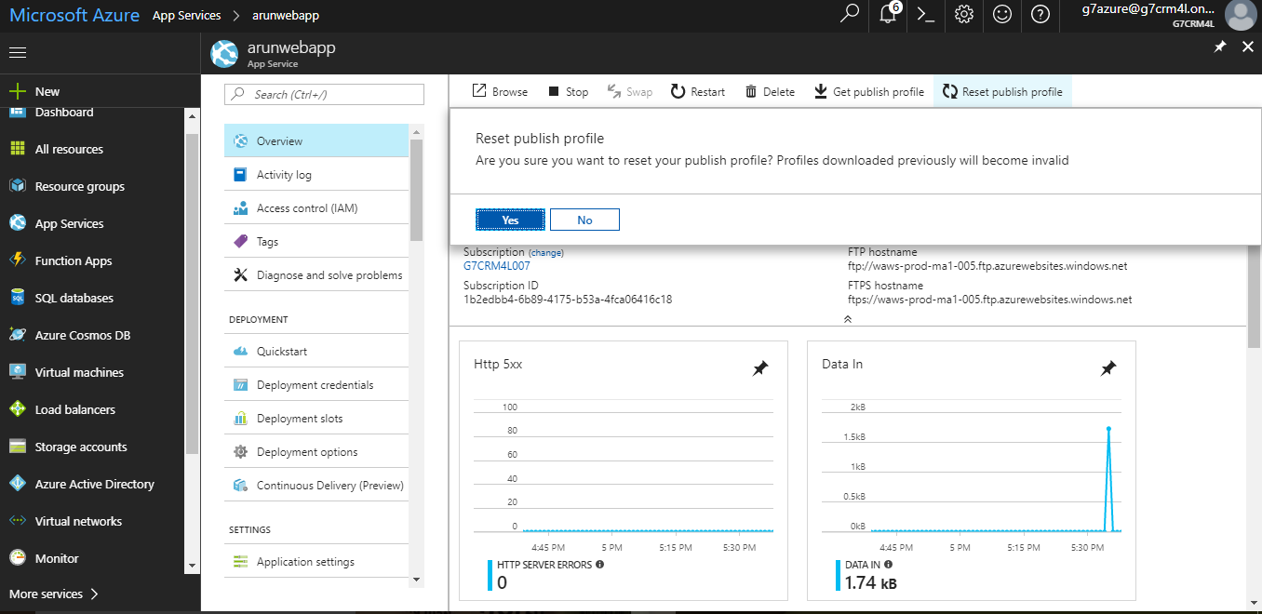

Now we have to download our public profile.Click Get Public Profie.It will download you a file

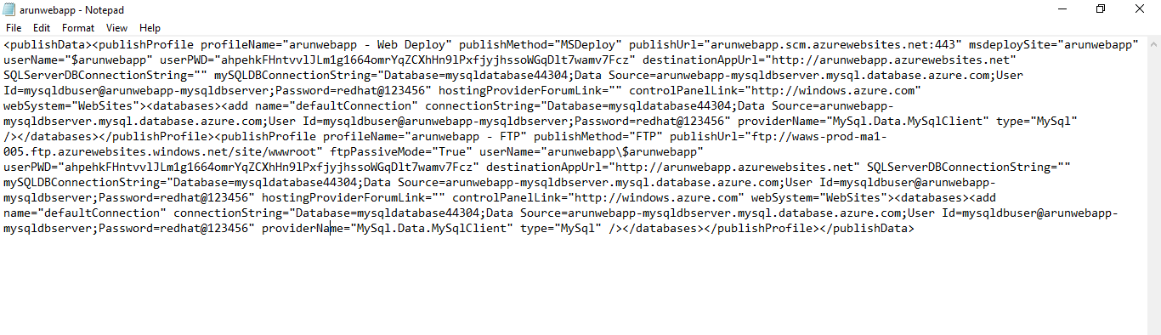

Open filezilla and connect to webapp by using credentials obtained from that file.

Hostname: use the publish url from the file (eg:ftp://waws-prod-ma1-005.ftp.azurewebsites.windows.net/site/wwwroot)

Username:Use username next to it(eg: arunwebapp\$arunwebapp)

Password:Select user PWD from it(eg:ahpehkFHntvvlJLm1g1664omrYqZCXhHn9lPxfjyjhssoWGqDlt7wamv7Fcz)

Click on connect.

Now transfer the webcontents to it.(Before that delete the default page present in our webapp)

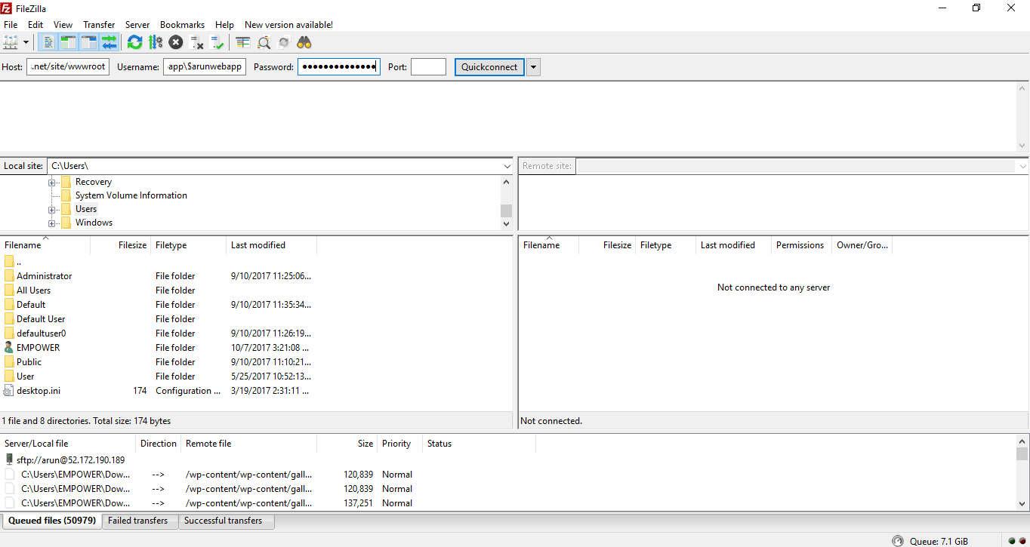

Next step is to import database.For that use Mysql workbench

Here type connection name(any name you want)

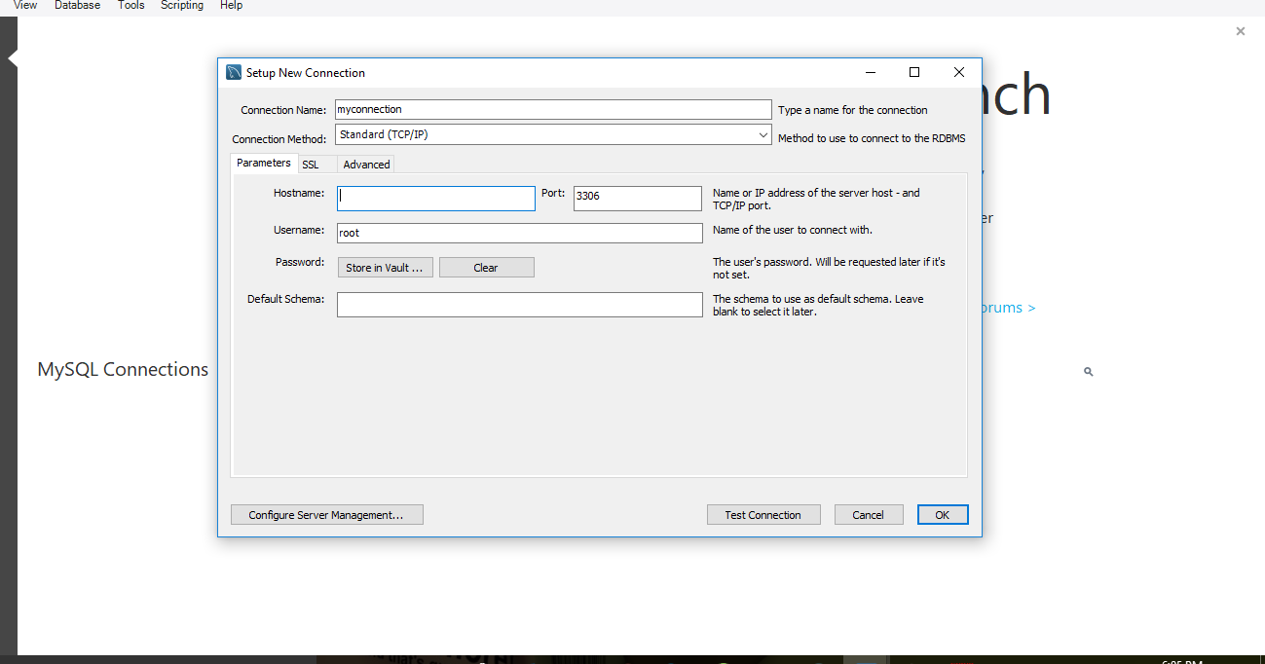

We can copy the hostname and username from our webapp database.

For that from your resource grop select mysqldatabase for your webapp

Click on Connection string.

From there under server you can get hostname and from uid you can get username

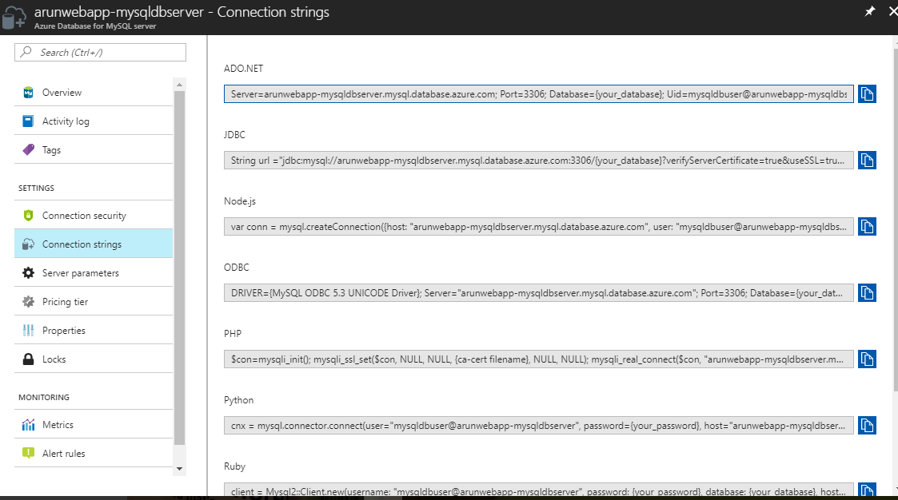

Click on storewalt to enter password for database that you have set earlier during database creation

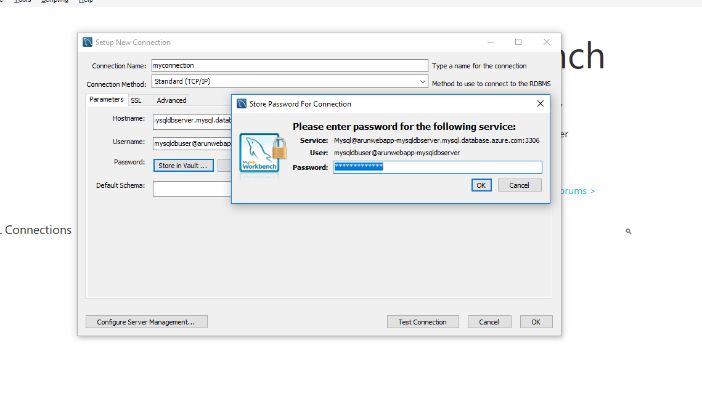

Click ok.Now you are able to acces database.

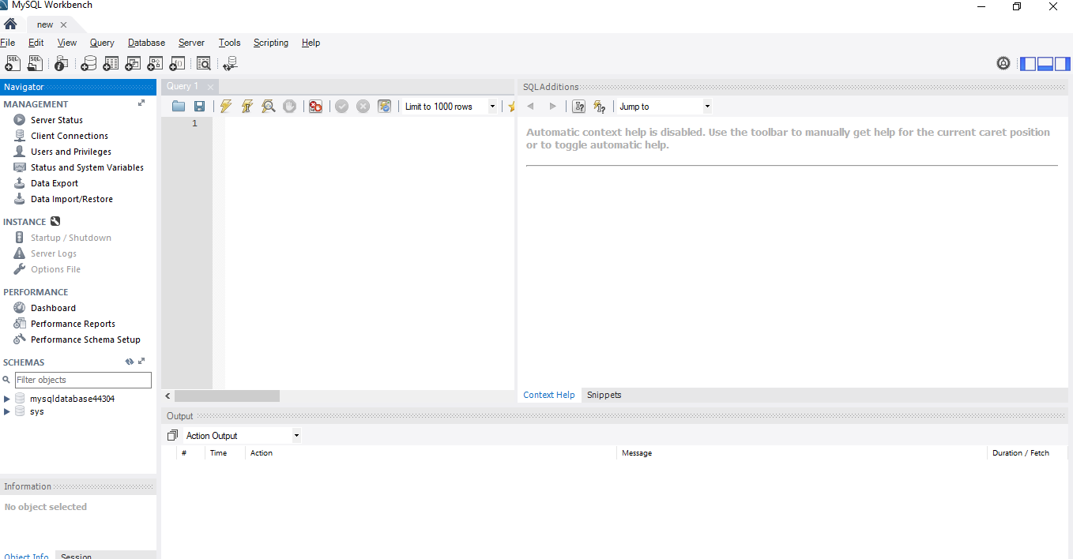

Now create a new schema.ie,database to import the sql file of our website

Go to server and select dataimport

And import the website sql file to the database we created

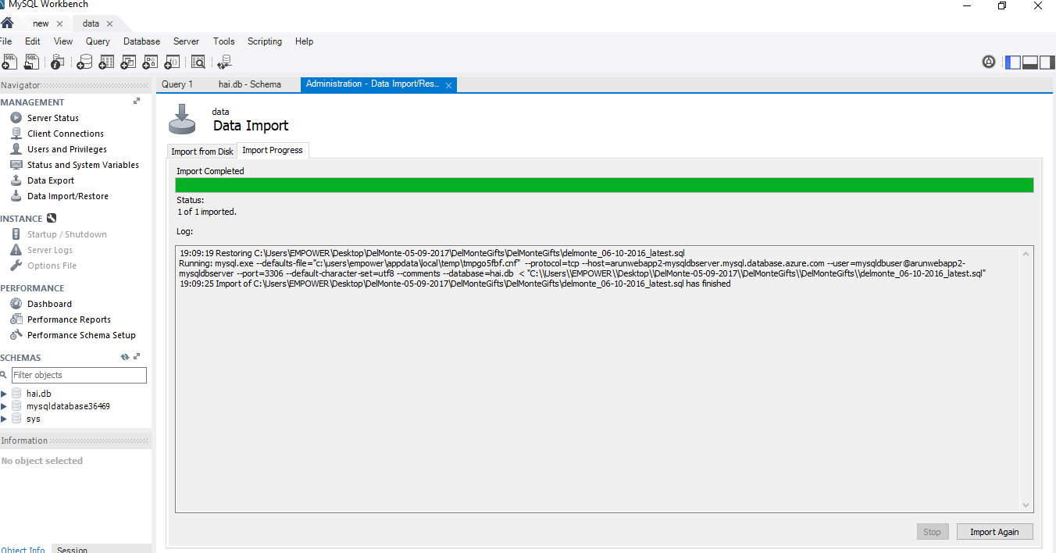

Next step is configuring our webapp configuration file to access database

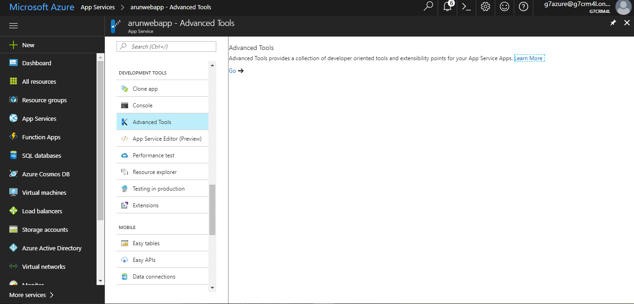

Click on Advanced tools and click go

Go to site>wwwroot>includes>functions.php

Here we want to enter hostname ,username,password(for newly created database),databasename(databse to which we imported site database file)

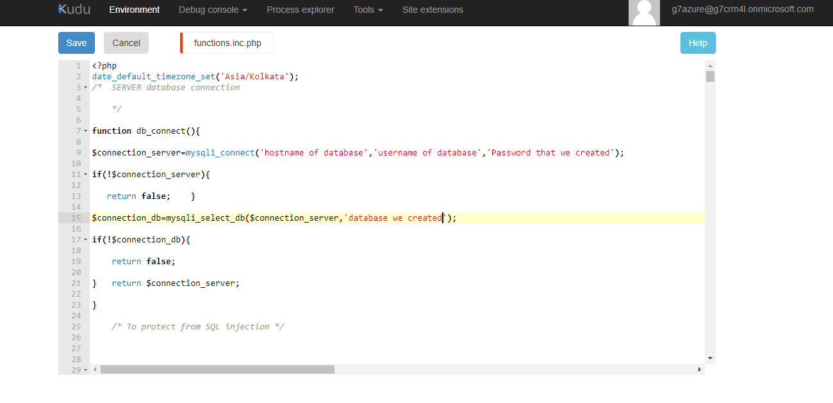

Save it

Now our webapp is ready.Just access through the url and we can see our site is ready